Acceptance Conformity for Radar 5 Sensor Test Equipment

Applicable for Radar 5 Sensor Test Equipment
with 77 G1.3 Corner Fixture
EPT-RDR05G1.3-01-01/EPT-RDR05G1.3-01-02

RESTRICTED ACCESS

DISTRIBUTION :
Firm Recipient Copies
CFM Jason Cai 1
CFM Cecilia Xia 1
CFM Daniel Wang 1
CFM Steven Wu 1

REVISION

Revision Date Author Comments

A XXXX-XX-XX XXXXX XXX Initial Release

CONTENTS

1. REFERENCE 4
2. OBjective 4
3. Method of measurement 5
4. List of the ACCEPTANCE CRITERIA for SENSOR TEST EQUIPMENT 5
5. Conclusion 5

REFERENCE

Trial date : XXXX/XX/XX

Trial done by : Jason Cai

Line : Radar 5

Station: Sensor Test

Software: Labwindows CVI, Teststand,

OBjective
Verify the conformity of the Radar 5 Sensor Test with the production requirements and validate it can be used for production.
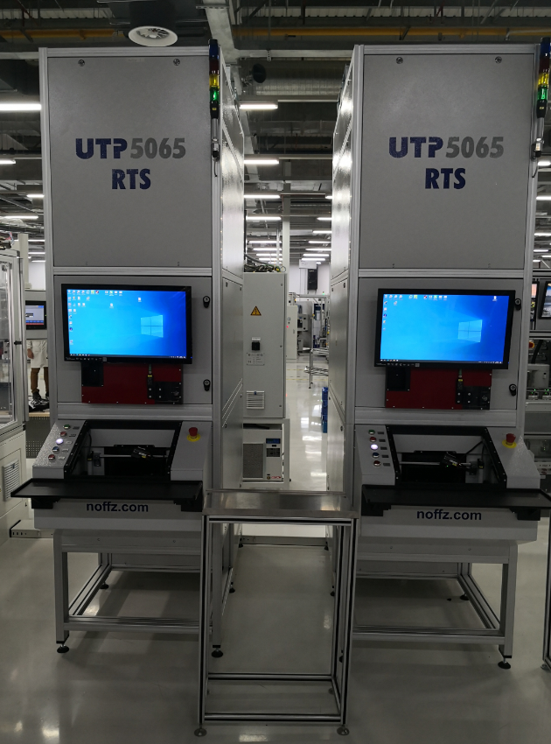

Method of measurement
The acceptance criteria has been defined and listed for the Sensor Test equipment and the system will be verified to meet the acceptance criteria.

List of the ACCEPTANCE CRITERIA for SENSOR TEST EQUIPMENT
See the attached file.
List of the Acceptance Criteria for Radar 5 Sensor Test.

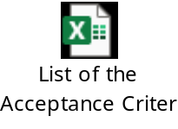

Conclusion
Radar 5 Sensor Test equipment is conformed to meet the acceptance criteria and production requirements.

